Practice Opening Hours

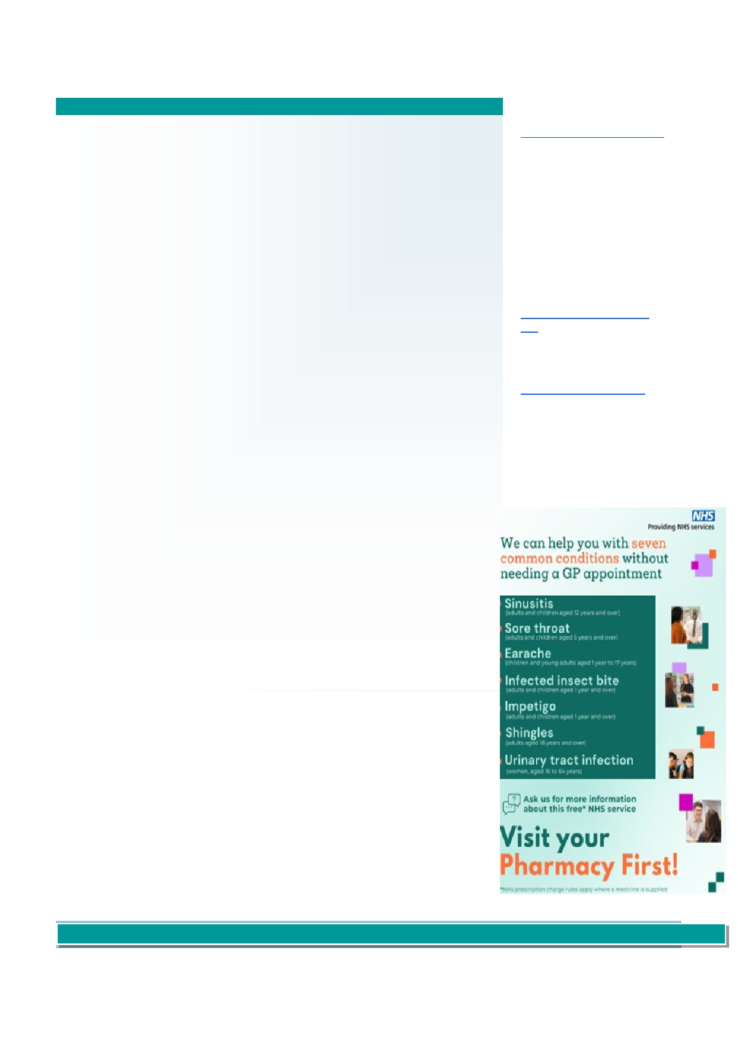

Solent View Medical Practice

Monday—Friday 8am—6.00pm

June Newsletter 2025

Summer is just around the corner

With the warmer weather hopefully upon us, it is important to remember there can be health risks.

Heat can affect many people, however most at risk are vulnerable people :

Telephone Lines are manned

until 6.30pm

If you require urgent medical

assistance when the practice is

closed, please call 111 or visit

www.111.nhs.uk

You can use the NHS 111

Older people—especially those over 75 symptom checker if you are

unsure if you need to be seen:

Those who live on their own [Check your symptoms - NHS](https://111.nhs.uk/triage/check-your-symptoms)

[111](https://111.nhs.uk/triage/check-your-symptoms)

People who have a serious or long-term illness including heart and lung conditions, diabetes,

kidney disease, Parkinson's disease or some mental health conditions For children, you can use the

Healthier Together app to re-

People who are on multiple medicines that may make them more likely to be badly affected by view symptoms:

hot weather [Home :: Healthier Together](https://www.what0-18.nhs.uk/)

Those who may find it hard to keep cool—babies and the very young, the bed bound, those

with drug or alcohol addictions or with Alzheimer's disease

People who spend a lot of time outside or in hot places—those who live in a top-floor flat, the

homeless and those whose jobs are outside

Tips for staying cool

Keep out of the heat, especially between 11am and 3pm, wear sunscreen, a hat and light

clothes, and avoid exercise or activity that makes you hot

Cool yourself down. Have cold food and drinks, avoid alcohol, caffeine and hot drinks, and

have a cool shower or put cool water on your skin or clothes

Close windows during the day and open them at night when the temperature outside is cooler.

Electric fans can help reduce temperatures

Pharmacy First Service

This service was first introduced in January 2024 and provided GP Practices the ability to refer

patients to obtain certain prescription medications directly from a pharmacy, without the need for a

GP appointment. Patients who contact the practice with any of the symptoms shown opposite,

maybe offered a referral to a local Pharmacy so that advice and treatment can be obtained.

The Pharmacy First Service also includes NHS Blood Pressure Check Services for people aged 40 and over, and the Pharmacy Contraception Service.

Staff Update

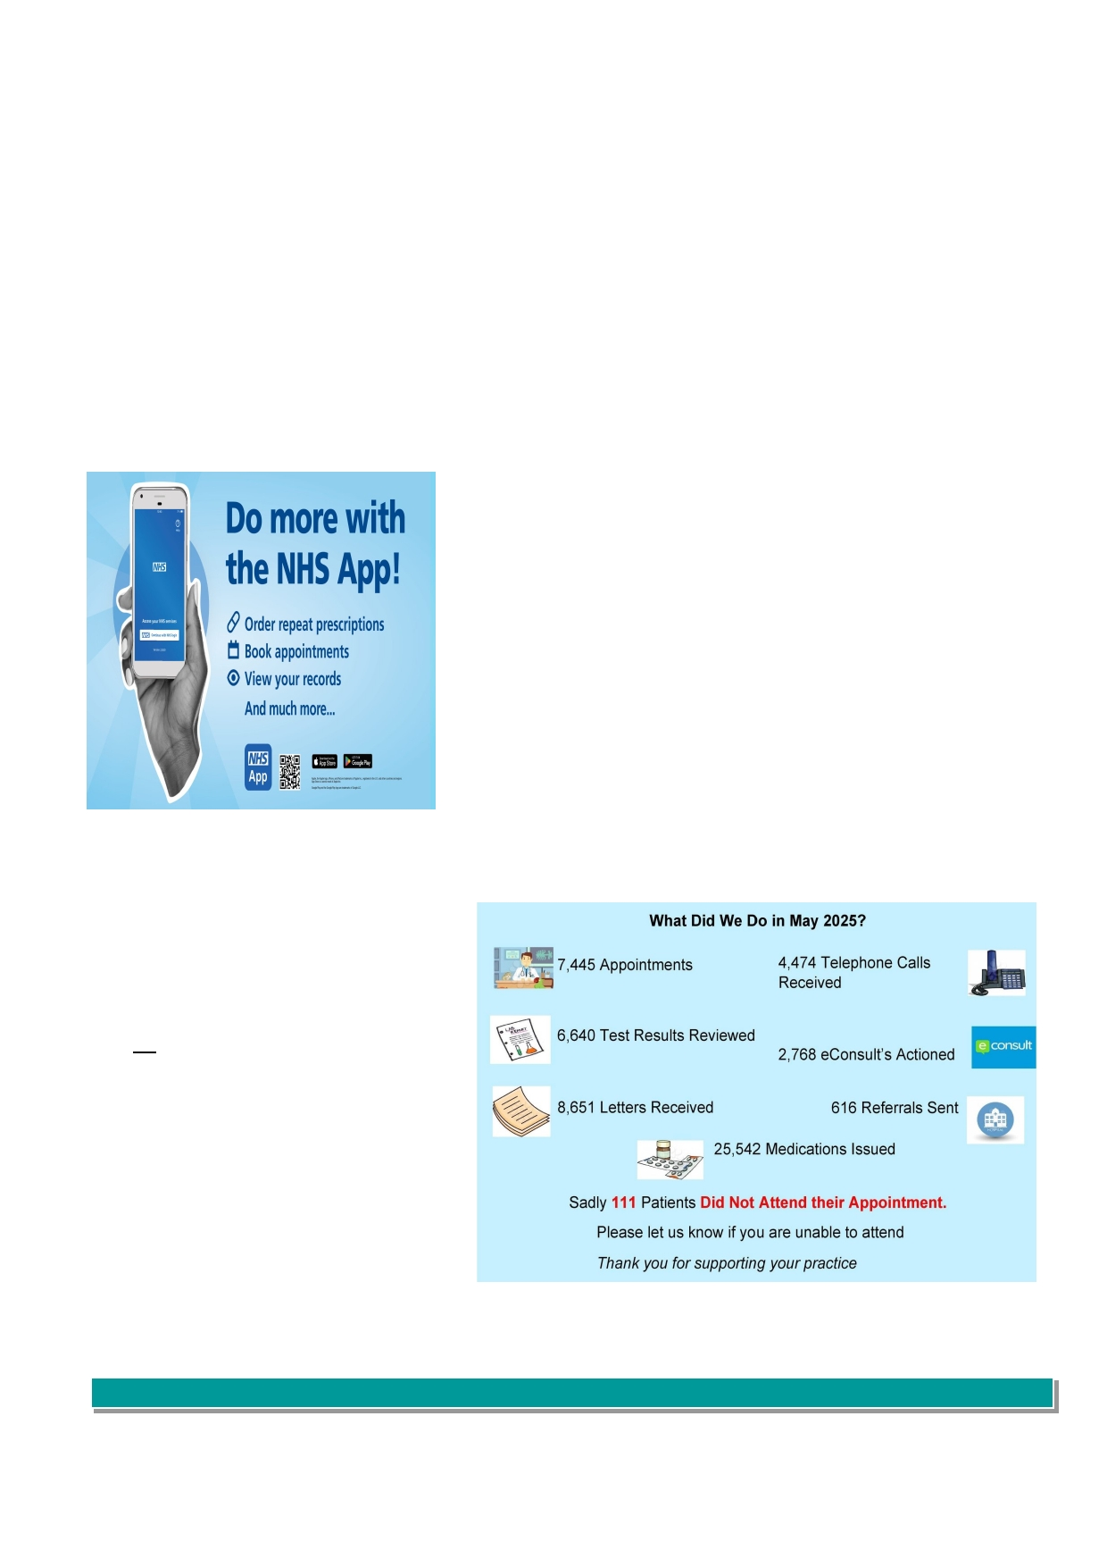

We are delighted to welcome Dr Lara Pilbeam as a salaried GP to our Team of Doctors at the practice. Dr Pilbeam first came to the practice in 2023 as part of her GP Trainee course, and we were delighted that she chose to re-join us since qualifying as a GP in August 2024.

In the past the Practice has seen a number of newly qualified Doctors join our Team to undertake part of their ongoing training process. In March

and April this year we welcomed Dr Adewale Olu-Eddo and Dr George Edwards. Dr Olu-Eddo, who is under the leadership of Dr Mark Farrington, is

currently in his second year of the Specialty Training Programme to build his clinical skills, knowledge and professional approach. Dr George Edwards is in his second Foundation Year under the leadership of Dr Michelle Clarke, and is undertaking increasing responsibilities f or patient care.

We are also very proud of other members of our Clinical Team who have also completed training; Debbie Humphreys is now an Advanced Nurse Practitioner, Laura Dodd is now a Nurse Associate, and Isla Hadley is in the process of the Trainee Nurse Associate course.

NHS APP

The NHS App allows patients who are over the age of 13 years of age and registered with a GP surgery in England, to access services online on their computer, tablet or mobile phone.

Anyone registered can:

• Order repeat prescriptions

• Book and manage appointments

• Get health information and advice

• View their own health record securely

What we did in May 2025

Sadly the practice is experiencing a high number of missed

appointments with all our Healthcare Professionals. Last month **111** patients did not attend their appointment.

Please let us know if you are unable to attend so that the appointment can be offered to someone else.

Appointments can be cancelled via the NHS App and by phoning the practice on 02392 552200.

Your feedback counts

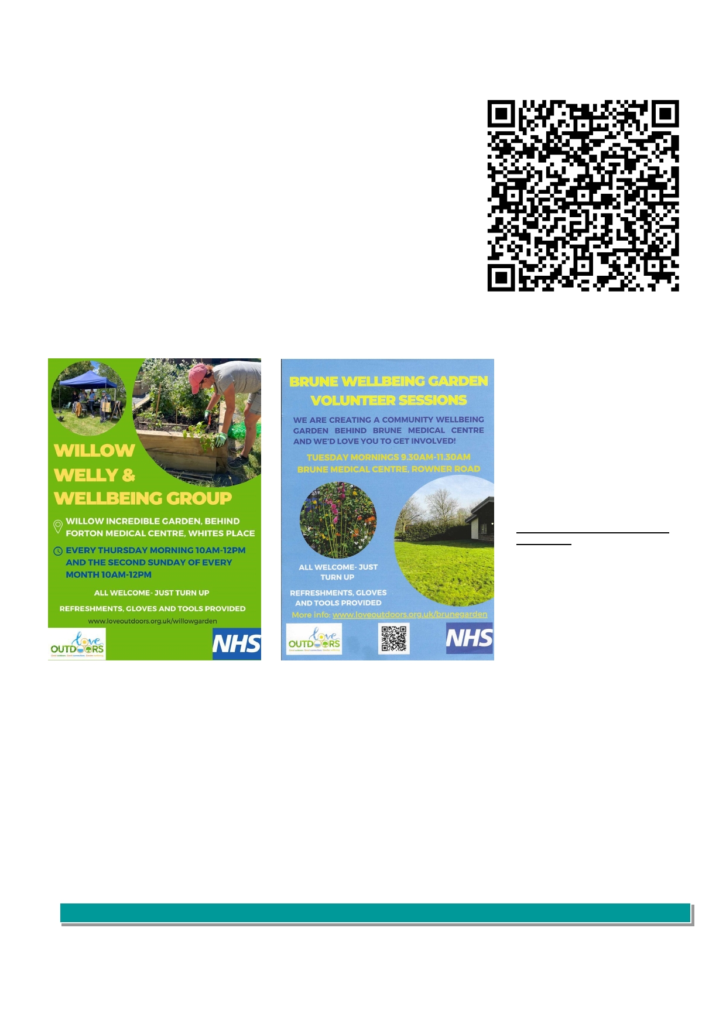

We value feedback from our patients. If you would like to provide feedback concerning

anything to do with the practice, there are a couple of ways to do this:

• If you have a smartphone, scan the QR code opposite using the camera on your

phone and click on the link. Complete the digital form and submit

• Visit our practice website at www.solentviewmedicalpractice.co.uk and complete

the suggestion form online

• Paper feedback forms can be found at reception to complete and post in the box

provided

Willow and Brune Wellbeing Garden

If you enjoy a spot of gardening, why not

pop along to the Willow Welly & Wellbeing

Group or Brune Wellbeing Garden .

Both gardens are open to all patients

within the Gosport and Lee-on-the-Solent

locality. Refreshments, gloves and tools are provided.

We are proud to advise the gardens

featured recently on BBC News website [https://www.bbc.co.uk/news/articles/](https://gbr01.safelinks.protection.outlook.com/?url=https%3A%2F%2Fwww.bbc.co.uk%2Fnews%2Farticles%2Fc4gr6dql8dgo&data=05%7C02%7Cbeverley.glass%40nhs.net%7C6e13fc788b5841fee62d08dda8be8822%7C37c354b285b047f5b22207b48d774ee3%7C0%7C0%7C638852258481798719%7CUnkno)

[c4gr6dql8dgo](https://gbr01.safelinks.protection.outlook.com/?url=https%3A%2F%2Fwww.bbc.co.uk%2Fnews%2Farticles%2Fc4gr6dql8dgo&data=05%7C02%7Cbeverley.glass%40nhs.net%7C6e13fc788b5841fee62d08dda8be8822%7C37c354b285b047f5b22207b48d774ee3%7C0%7C0%7C638852258481798719%7CUnkno)

COVID Vaccination Programme 2025

We are pleased to inform patients the practice will be providing COVID vaccinations to eligible patients. Vaccinations will start in October and will be offered to patients at the time of the flu vaccination.

We understand that patients are keen to get their appointment booked, however we are unable to book these appointments at the moment and further

information will be provided once we have received communication from NHS England and the Hampshire & Isle of Wight Vaccine Operation Centre.